**INSTITUTE OF ENGINEERING & TECHNOLOGY**

**MOHANLAL SUKHADIA UNIVERSITY, UDAIPUR**

**(RAJ.)**

***DEPARTMENT OF COMPUTER SCIENCE ENGINEERING***

***B. Tech - IV SEMESTER***



**Session 2022-23**

**Network Programming Lab**

**LABORATORY MANUAL**

**BT4CS09-CP03**

**Prepared by:**

**Shivam Chouhan**

**INDEX**

|  |  |  |
| --- | --- | --- |
| S.No. | Topic | Page No. |
| 1. | Networks and Network Equipment | 3 |
| 2. | Network Topologies | 11 |
| 3. | Point Installation and Configurations | 15 |
| 4. | Peer to Peer Connection | 20 |
| 5. | Hub Lan Connection | 22 |
| 6. | Switch Lan Connection | 24 |
| 7. | Bus Topology | 26 |
| 8. | Ring Topology | 28 |
| 9. | Mesh Topology | 30 |
| 10. | C program to implement Error Detection Technique using checksum calculation | 32 |
| 11. | C program to implement bit stuffing | 34 |
| 12. | C program to implement byte stuffing | 35 |
| 13. | C program to implement error detection and error correction technique using CRC | 36 |

**Experiment 1- Networks and Network Equipment**

**Practical No. 1**

**Aim:** Study of different type of Networks and Network Equipment.

**Description:**

**Types of Networks**

**a) Personal Area Network**

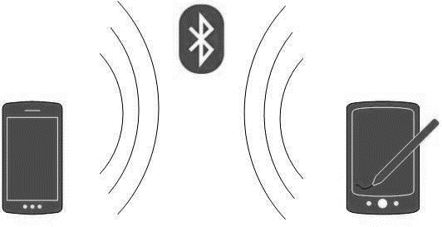A Personal Area Network (PAN) is smallest network which is very personal to a user. This may include Bluetooth enabled devices or infra-red enabled devices. PAN has connectivity range up to 10 meters. PAN may include wireless computer keyboard and mouse, Bluetooth enabled headphones, wireless printers and TV remotes.

For example, Piconet is Bluetooth-enabled Personal Area Network which may contain up to 8 devices connected together in a master-slave fashion.

**b) Local Area Network**

A computer network spanned inside a building and operated under single administrative system

is generally termed as Local Area Network (LAN). Usually, LAN covers an organization’ offices, schools, colleges or universities. Number of systems connected in LAN may vary from as least as two to as much as 16 million. LAN provides a useful way of sharing the resources between end users. The resources such as printers, file servers, scanners, and internet are easily sharable among computers.

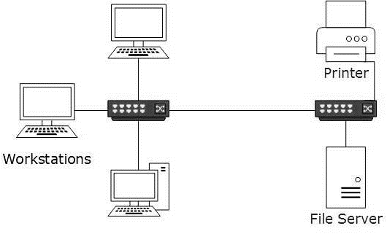

* LANs are composed of inexpensive networking and routing equipment. It may contain local servers serving file storage and other locally shared applications. It mostly operates on private IP addresses and does not involve heavy routing. LAN works under its own local domain and controlled centrally.
* LAN uses either Ethernet or Token-ring technology. Ethernet is most widely employed LAN technology and uses Star topology, while Token-ring is rarely seen.
* LAN can be wired, wireless, or in both forms at once.

**c) Metropolitan Area Network**

The Metropolitan Area Network (MAN) generally expands throughout a city such as cable TV network. It can be in the form of Ethernet,Token-ring, ATM, or Fiber Distributed Data Interface (FDDI).

Metro Ethernet is a service which is provided by ISPs. This service enables its users to expand their Local Area Networks. For example, MAN can help an organization to connect all of its offices in a city.

Backbone of MAN is high-capacity and high-speed fiber optics. MAN works in between Local Area Network and Wide Area Network. MAN provides uplink for LANs to WANs or internet.

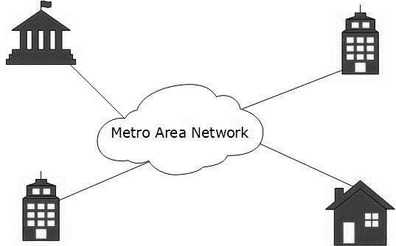

**d) Wide Area Network**

As the name suggests, the Wide Area Network (WAN) covers a wide area which may span across provinces and even a whole country. Generally, telecommunication networks are Wide Area Network. These networks provide connectivity to MANs and LANs. Since they are equipped with very high-speed backbone, WANs use very expensive network equipment.

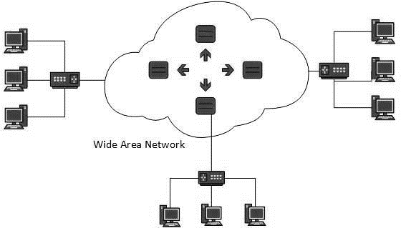

WAN may use advanced technologies such as Asynchronous Transfer Mode (ATM), Frame Relay, and Synchronous Optical Network (SONET). WAN may be managed by multiple administration.

**e) Internetwork**

* A network of networks is called an internetwork, or simply the internet. It is the largest network in existence on this planet.The internet hugely connects all WANs and it can have connection to LANs and Home networks. Internet uses TCP/IP protocol suite and uses IP as its addressing protocol. Present day, Internet is widely implemented using IPv4. Because of shortage of address spaces, it is gradually migrating from IPv4 to IPv6.
* Internet enables its users to share and access enormous amount of information worldwide. It uses WWW, FTP, email services, audio and video streaming etc. At huge level, internet works on Client-Server model.
* Internet uses very high speed backbone of fiber optics. To inter-connect various continents, fibers are laid under sea known to us as submarine communication cable.
* Internet is widely deployed on World Wide Web services using HTML linked pages and is accessible by client software known as Web Browsers. When a user requests a page using some web browser located on some Web Server anywhere in the world, the Web Server responds with the proper HTML page. The communication delay is very low.
* Internet is serving many proposes and is involved in many aspects of life. Some of them are:
* Web sites
* E-mail
* Instant Messaging
* Blogging
* Social Media
* Marketing
* Networking
* Resource Sharing
* Audio and Video Streaming

**1) Inter-connectivity**- Components of a network can be connected to each other differently in some fashion. By connectedness we mean either logically , physically , or both ways.

* Every single device can be connected to every other device on network, making the network mesh.
* All devices can be connected to a single medium but geographically disconnected, created bus like structure.
* Each device is connected to its left and right peers only, creating linear structure.
* All devices connected together with a single device, creating star like structure.
* All devices connected arbitrarily using all previous ways to connect each other, resulting in a hybrid structure.

**2) Administration**- From an administrator’s point of view, a network can be private network which belongs a single autonomous system and cannot be accessed outside its physical or logical domain.A network can be public which is accessed by all.

**3) Architecture-** Computer networks can be discriminated into various types such as Client- Server,peer-to-peer or hybrid, depending upon its architecture.

* There can be one or more systems acting as Server. Other being Client, requests the Server to serve requests.Server takes and processes request on behalf of Clients.
* Two systems can be connected Point-to-Point, or in back-to-back fashion. They both reside at the same level and called peers.
* There can be hybrid network which involves network architecture of both the above type

**Network Applications**

Computer systems and peripherals are connected to form a network.They provide numerous advantages:

* Resource sharing such as printers and storage devices
* Exchange of information by means of e-Mails and FTP
* Information sharing by using Web or Internet
* Interaction with other users using dynamic web pages
* IP phones
* Video conferences
* Parallel computing
* Instant messaging

**Computer Network Components**

Computer networks components comprise both physical parts(hardware) as well as the software required for installing computer networks, both at organizations and at home. The hardware components are the server, client, peer, transmission medium, and connecting devices. The software components are operating system and protocols.

**a) Computer Network Hardware/Equipments**

Networking hardware, also known as network equipment or computer networking devices, are electronic devices which are required for communication and interaction between devices on a [computer network](https://en.wikipedia.org/wiki/Computer_network). Specifically, they mediate [data transmission](https://en.wikipedia.org/wiki/Data_transmission) in a computer network.

Network Hardware Components

1. **Servers:** Servers are high-configuration computers that manage the resources of the network. The network operating system is typically installed in the server and so they give user accesses to the network resources. Servers can be of various kinds: file servers, database servers, print servers etc.
2. **Clients:** Clients are computers that request and receive service from the servers to access and use the network resources.
3. **Peers:** Peers are computers that provide as well as receive services from other peers in a workgroup network.
4. **Transmission Media:** Transmission media are the channels through which data is transferred from one device to another in a network. Transmission media may be guided media like coaxial cable, fibre optic cables etc; or maybe unguided media like microwaves, infra-red waves etc.
5. **Network Interface Unit(NIC):** Each computer in a network has a special expansion card called a network interface card (NIC). The NIC prepares(formats) and sends data, receives data, and controls data flow between the computer and the network. On the transmit side, the NIC passes frames of data on to the physical layer, which transmits the data to the physical link. On the receiver's side, the NIC processes bits received from the physical layer and processes the message based on its contents.

It can support a transfer rate of 10,100 to 1000 Mb/s.The MAC address or physical address is encoded on the network card chip which is assigned by the IEEE to identify a network card uniquely. The MAC address is stored in the PROM (Programmable read-only memory).

* There are two types of NIC:

1. **Wired NIC:** The Wired NIC is present inside the motherboard. Cables and connectors are used with wired NIC to transfer data.
2. **Wireless NIC:** The wireless NIC contains the antenna to obtain the connection over the wireless network. For example, laptop computer contains the wireless NIC.

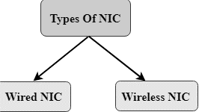

6. **Connecting Devices:** Connecting devices act as middleware between networks or computers, by

binding the network media together. Some of the common connecting devices are:

1. **Repeater** – A repeater operates at the physical layer. Its job is to regenerate the signal over the same network before the signal becomes too weak or corrupted so as to extend the length to which the signal can be transmitted over the same network. An important point to be noted about repeaters is that they do not amplify the signal. When the signal becomes weak, they copy the signal bit by bit and regenerate it at the original strength. It is a 2 port device.
2. **Hub** – A hub is basically a multiport repeater. A hub connects multiple wires coming from different branches, for example, the connector in star topology which connects different stations. Hubs cannot filter data, so data packets are sent to all connected devices. In other words, [collision domain](https://en.wikipedia.org/wiki/Collision_domain) of all hosts connected through Hub remains one. Also, they do not have intelligence to find out best path for data packets which leads to inefficiencies and wastage.

* Types of Hub
  1. **Active Hub:-** These are the hubs which have their own power supply and can clean, boost and relay the signal along with the network. It serves both as a repeater as well as wiring centre. These are used to extend the maximum distance between nodes.
  2. **Passive Hub :-** These are the hubs which collect wiring from nodes and power supply from active hub. These hubs relay signals onto the network without cleaning and boosting them and can’t be used to extend the distance between nodes.

3) **Bridge** – A bridge operates at data link layer. A bridge is a repeater, with add on the functionality of filtering content by reading the MAC addresses of source and destination. It is also used for interconnecting two LANs working on the same protocol. It has a single input and single output port, thus making it a 2 port device.

Types of Bridges:-

1. **Transparent Bridges:-** These are the bridge in which the stations are completely unaware of the bridge’s existence i.e. whether or not a bridge is added or deleted from the network, reconfiguration of the stations is unnecessary. These bridges make use of two processes i.e. bridge forwarding and bridge learning.
2. **Source Routing Bridges:-** In these bridges, routing operation is performed by source station

and the frame specifies which route to follow. The hot can discover frame by sending a special frame called discovery frame, which spreads through the entire network using all possible paths to destination.

4) **Switch** – A switch is a multiport bridge with a buffer and a design that can boost its efficiency(a large number of ports imply less traffic) and performance. A switch is a data link layer device. The switch can perform error checking before forwarding data, that makes it very efficient as it does not forward packets that have errors and forward good packets selectively to correct port only. In other words, switch divides collision domain of hosts, but [broadcast domain](https://en.wikipedia.org/wiki/Broadcast_domain) remains same.

5) [**Routers**](https://www.geeksforgeeks.org/network-devices-hub-repeater-bridge-switch-router-gateways/#Routers) **–** A router is a device like a switch that routes data packets based on their IP addresses. Router is mainly a Network Layer device. Routers normally connect LANs and WANs together and have a dynamically updating routing table based on which they make decisions on routing the data packets. Router divide broadcast domains of hosts connected through it.

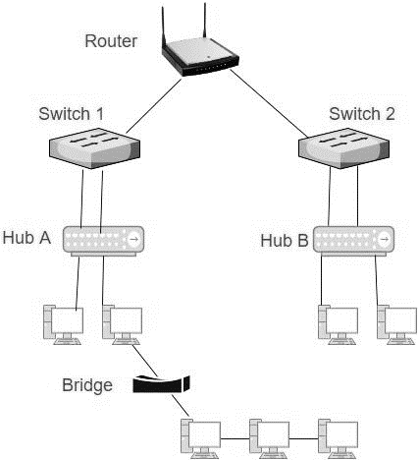

6) **Gateway** – A gateway, as the name suggests, is a passage to connect two networks together that may work upon different networking models. They basically work as the messenger agents that take data from one system, interpret it, and transfer it to another system. Gateways are also called protocol converters and can operate at any network layer. Gateways are generally more complex than switch or router.

**b) Computer Network Software**

Network software encompasses a broad range of software used for design, implementation, and operation and monitoring of computer networks.

Network Software Components

**1) Networking Operating System:** Network Operating Systems is typically installed in the server and facilitate workstations in a network to share files, database, applications, printers etc.

**2) Protocol Suite:** A protocol is a rule or guideline followed by each computer for data communication. Protocol suite is a set of related protocols that are laid down for computer networks. The two popular protocol suites are:

a. OSI Model ( Open System Interconnections)

b. TCP / IP Model

**Experiment 2- Network Topologies**

**Practical No. 2**

**Aim:** Study and verification of standard Network Topologies i.e. Star, Bus, Ring, Mesh etc.

**Description:**

**Network Topologies**

The arrangement of a network which comprises of nodes and connecting lines via sender and receiver is referred as network topology. The various network topologies are :

**a) Mesh Topology :**

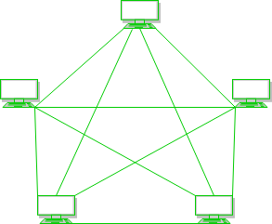In mesh topology, every device is connected to another device via particular channel.

Every device is connected with another via dedicated channels. These channels are known as links.

* If suppose, N number of devices are connected with each other in mesh topology, then total number of ports that is required by each device is N-1. In the Figure 1, there are 5 devices connected to each other, hence total number of ports required is 4.
* If suppose, N number of devices are connected with each other in mesh topology, then total number of dedicated links required to connect them is NC2 i.e. N(N-1)/2. In the Figure 1, there are 5 devices connected to each other, hence total number of links required is 5*4/2 = 10.
* **Advantages of this topology :**
* It is robust.
* Fault is diagnosed easily. Data is reliable because data is transferred among the devices through dedicated channels or links.
* Provides security and privacy.
* **Problems with this topology :**
* Installation and configuration is difficult.
* Cost of cables are high as bulk wiring is required, hence suitable for less number of devices.
* Cost of maintenance is high.

**b) Star Topology :**

In star topology, all the devices are connected to a single hub through a cable. This hub is the central node and all others nodes are connected to the central node. The hub can be passive in nature i.e. not intelligent hub such as broadcasting devices, at the same time the hub can be intelligent known as active hubs. Active hubs have repeaters in them.

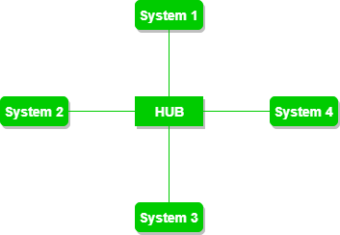

A star topology having four systems connected to single point of connection i.e. hub.

**Advantages of this topology :**

* If N devices are connected to each other in star topology, then the number of cables required to connect them is N. So, it is easy to set up.
* Each device require only 1 port i.e. to connect to the hub.

**Problems with this topology :**

* If the concentrator (hub) on which the whole topology relies fails, the whole system will crash down.
* Cost of installation is high.
* Performance is based on the single concentrator i.e. hub.

**C) Bus Topology :**

Bus topology is a network type in which every computer and network device is connected to single cable. It transmits the data from one end to another in single direction. No bi-directional feature is in bus topology.

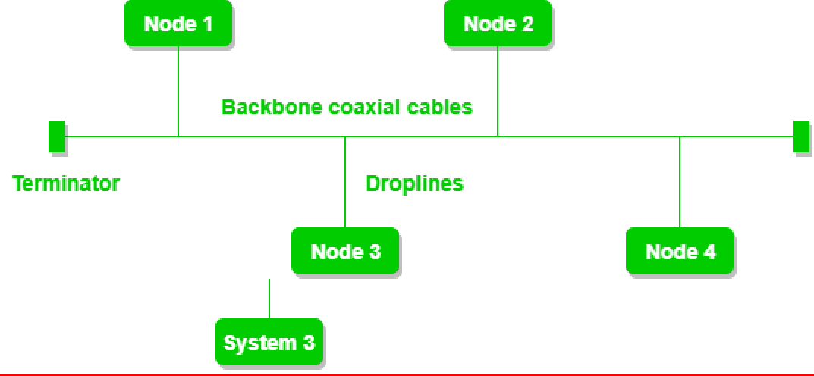

A bus topology with shared backbone cable. The nodes are connected to the channel via drop lines.

* **Advantages of this topology :**
* If N devices are connected to each other in bus topology, then the number of cables required to connect them is 1 which is known as backbone cable and N drop lines are required.
* Cost of the cable is less as compared to other topology, but it is used to built small networks.
* **Problems with this topology :**
* If the common cable fails, then the whole system will crash down.
* If the network traffic is heavy, it increases collisions in the network. To avoid this, various protocols are used in MAC layer known as Pure Aloha, Slotted Aloha, CSMA/CD etc.

**D) Ring Topology :**

In this topology, it forms a ring connecting a devices with its exactly two neighbouring devices.

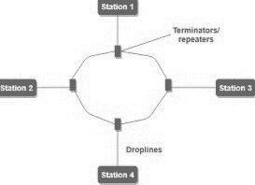

A ring topology comprises of 4 stations connected with each forming a ring..

The following operations takes place in ring topology are :

1. One station is known as **monitor** station which takes all the responsibility to perform the operations.
2. To transmit the data, station has to hold the token. After the transmission is done, the token is to be released for other stations to use.
3. When no station is transmitting the data, then the token will circulate in the ring.
4. There are two types of token release techniques : **Early token release** releases the token just after the transmitting the data and **Delay token release** releases the token after the acknowledgement is received from the receiver.

* **Advantages of this topology :**
* The possibility of collision is minimum in this type of topology.
* Cheap to install and expand.
* **Problems with this topology :**
* Troubleshooting is difficult in this topology.
* Addition of stations in between or removal of stations can disturb the whole topology.

**E) Hybrid Topology :**

This topology is a collection of two or more topologies which are described above. This is a scalable topology which can be expanded easily. It is reliable one but at the same it is a costly topology.

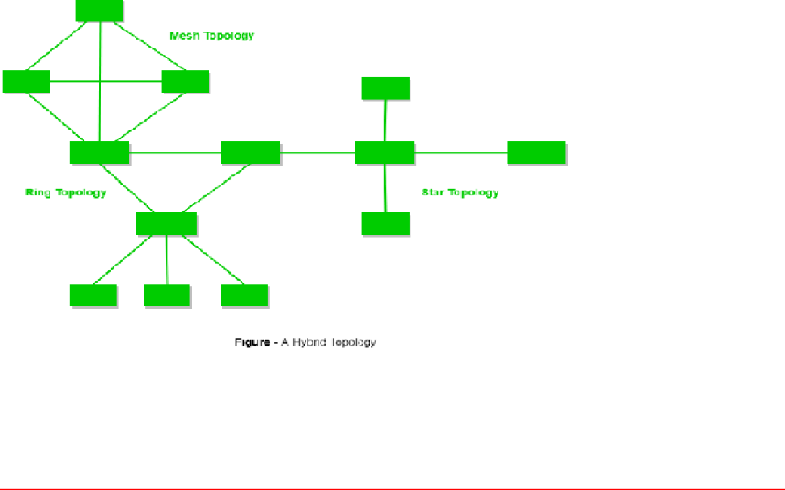

**Experiment 3- Point Installation and Configurations**

**Practical No. 3**

**Aim:** Study of point to point installation and configuration using Packet Tracer.

**Description:**

**Introduction of Packet Tracer**

**Packet Tracer** is a cross-platform visual simulation tool designed by Cisco Systems that allows users to create network typologies and imitate modern computer networks. The software allows users to simulate the configuration of Cisco routers and switches using a simulated command line interface.

Packet Tracer can also be run on Linux and Microsoft Windows and also macOS. Similar [Android](https://en.wikipedia.org/wiki/Android_(operating_system)) and [iOS](https://en.wikipedia.org/wiki/IOS) apps are also available. Packet Tracer allows users to create simulated network topologies by dragging and dropping routers, switches and various other types of network devices. A physical connection between devices is represented by a 'cable' item. Packet Tracer supports an array of simulated [Application Layer protocols](https://en.wikipedia.org/wiki/Application_Layer), as well as basic routing with [RIP](https://en.wikipedia.org/w/index.php?title=Routighdfghdfghng_Information_Protocol&action=edit&redlink=1), [OSPF](https://en.wikipedia.org/wiki/OSPF), [EIGRP](https://en.wikipedia.org/wiki/EIGRP), [BGP](https://en.wikipedia.org/wiki/BGP), to the extents required by the current [CCNA](https://en.wikipedia.org/wiki/CCNA) curriculum. As of version 5.3, Packet Tracer also supports the [Border Gateway Protocol](https://en.wikipedia.org/wiki/Border_Gateway_Protocol).

In addition to simulating certain aspects of [computer networks](https://en.wikipedia.org/wiki/Computer_networks), Packet Tracer can also be used for collaboration. As of Packet Tracer 5.0, Packet Tracer supports a multi-user system that enables multiple users to connect multiple topologies together over a [computer network](https://en.wikipedia.org/wiki/Computer_network). Packet Tracer also allows instructors to create activities that students have to complete. Packet Tracer is often used in educational settings as a learning aid. Cisco Systems claims that Packet Tracer is useful for network experimentation.

**Overview of LAN**

When two or more than two devices or computers or laptops are connected together they form a network. Local area network is a private network that operates within a building or Home or Office etc. Local area networks are widely used for sharing resources (Printer) or information among devices or computers which are connected in the network.

Local area networks (LANs) have become common place in the information age. The introduction of low-cost computers, along with the need to share information and hardware resources, in an office environment led the way to the development of inexpensive LAN technologies.

LAN technologies are designed to interconnect computers across short distances (e.g., within a single building or room). Today’s LANs are inexpensive, highly reliable, and easy to install and maintain.

To connect a computer to a LAN, a computer must have an interface card. The computer views this interface card as any other I/O device. Data sent to the interface card are transmitted onto the communication medium (copper wire, coax cable, optical fiber, or through the air at a given radio frequency), where it is then received by another computer attached to the same medium. The communication medium used is transparent to the application.

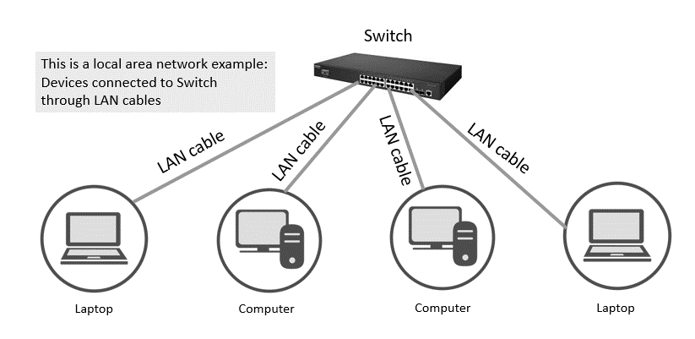

**General Steps of Configurations of LAN using Packet Tracer**

1. **Open Network Topology**: Once we have opened Network Topology on Cisco Packet Tracer, access network and identify the components of network, for example; Servers, Routers, End Devices, etc.

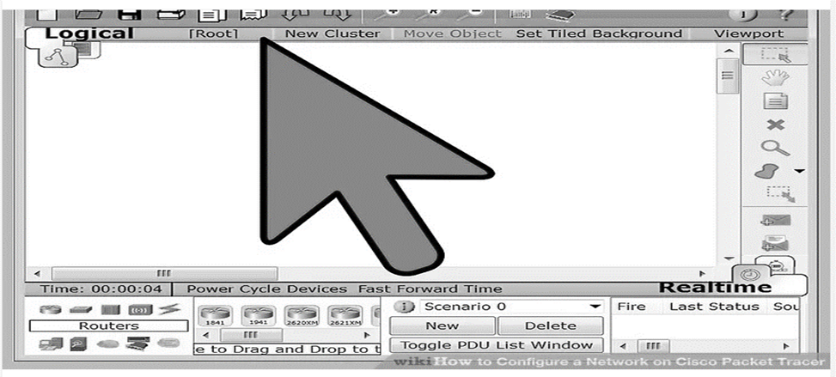

**2. Complete the cabling:** Access the cables section and connect completely and correctly the cables between the networks in order to ensure connectivity between the devices in the network using the connections table given.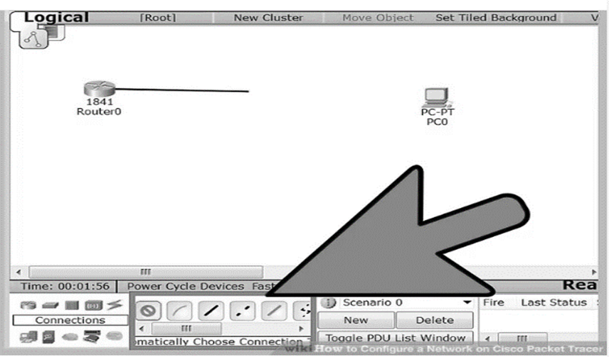

**3. Configure the IP addresses on the end devices:**Using the address table still, correctly and completely configure the IP addresses on all end devices. This can be done by accessing the desktop platform on each device and locating the IP configuration section. The reason for doing this is to enable the devices be on the right network.

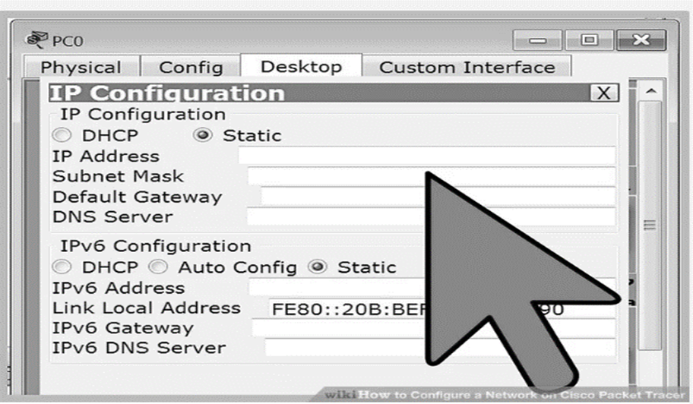

**4. Configure the IP addresses on your routers and switches:** After configuring the right IP addresses on the end devices, you will have to do the same on the routers and switches also, using the address table. But this time in a different way because there's no desktop platform on the routers and switches. You will have to access the configuration panel on both devices and this can be done in two ways:

Click on the device and open the Command Line Interface (CLI) and then type in the right commands to configure the right addresses for the router using the addressing table.

Use a console cable from an end device and connect it to the device you wish to configure and access the terminal platform on the end device and it will take you to the device's Command Line Interface and then you type in the commands in other to configure the right addresses.

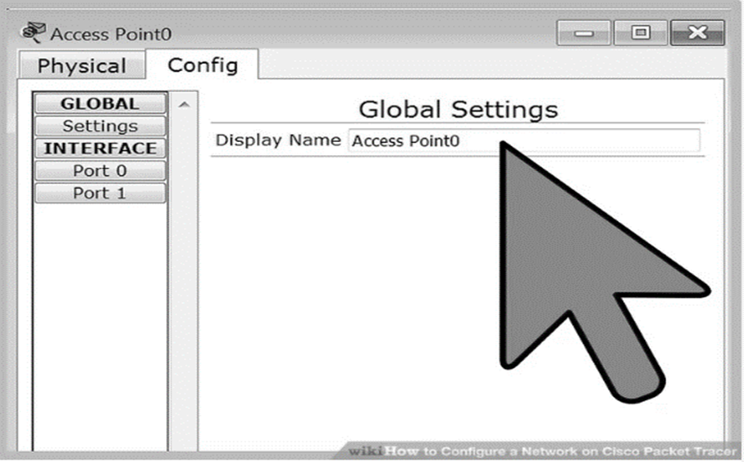

**5. Configure your default gateway.** After configuring the IP addresses, you will need to configure the default gateway also. The reason for this is so the end devices would know what network they are operating on. You can find the default gateway either in the addressing table (if given) or in the network topology.

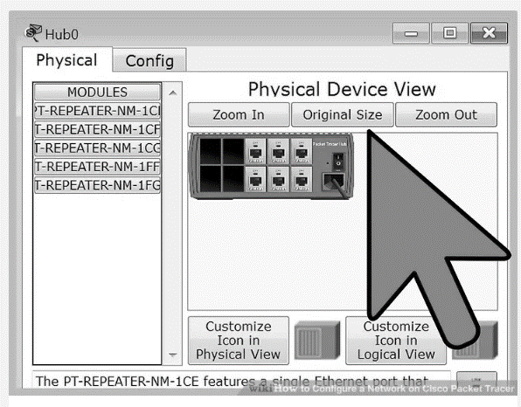

**6. Test connectivity:** After configuring the addresses, we will have to test connectivity by opening a command prompt window on the end devices and try pinging the address which the network operates on. If it gives us a reply, it means our network was configured correctly.

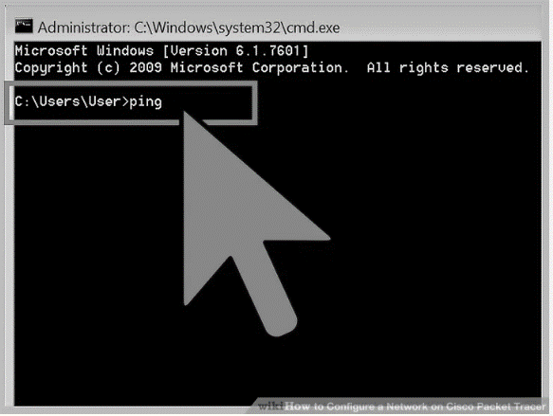

**Practical – 4**

**Aim**: Peer to Peer Connection

**Step 1**: Place the system and establish in peer-to-peer connection. Peers are computers that provide as well as receive services from other peers in a workgroup network. Access the cables section and connect completely and correctly the cables between the networks in order to ensure connectivity between the devices in the network using the connections table given.

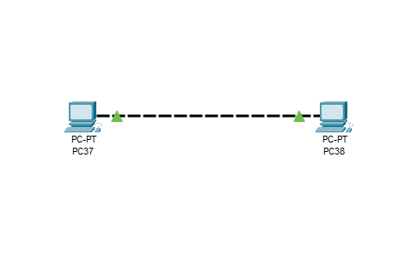

**Step 2**: Configure the IP addresses on the end devices. You will have to access the configuration panel on both devices.

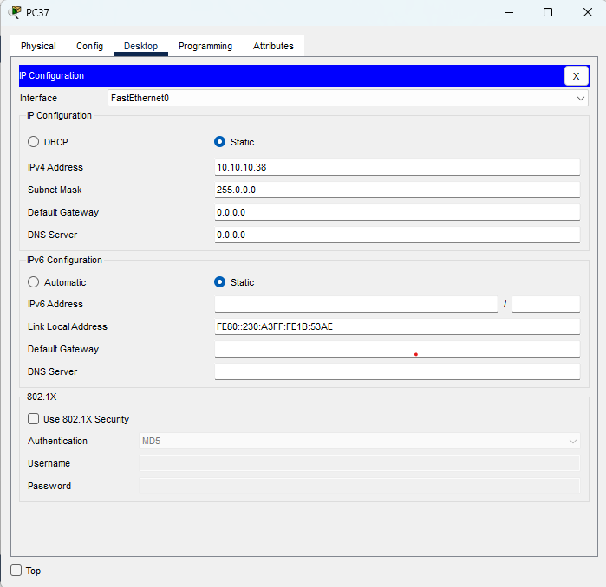

**Step 3**: **Test connectivity**: After configuring the addresses, we will have to test connectivity by opening a command prompt window on the end devices and try pinging the address which the network operates on. If it gives us a reply, it means our network was configured correctly.

**Syntax**: ping<ip_address>

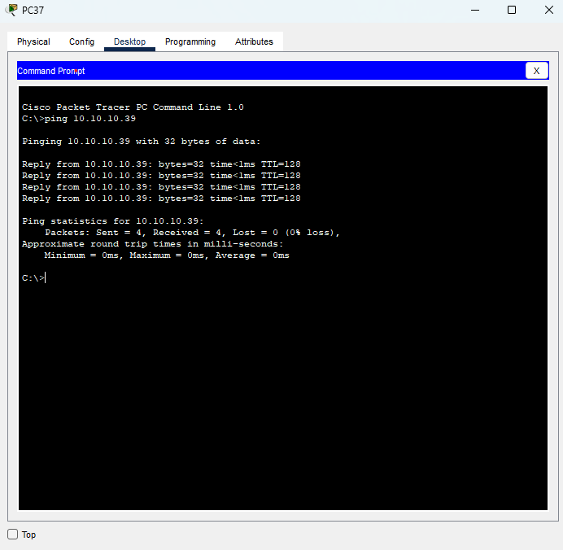

**Practical – 5**

**Aim**: Hub Lan Connection

**Step 1**: Place the system and establish in Hub Lan connection. A hub is basically a multiport repeater. A hub connects multiple wires coming from different branches. Hubs cannot filter data, so data packets are sent to all connected devices. In other words, collision domain of all hosts connected through Hub remains one. Also, they do not have intelligence to find out best path for data packets which leads to inefficiencies and wastage.

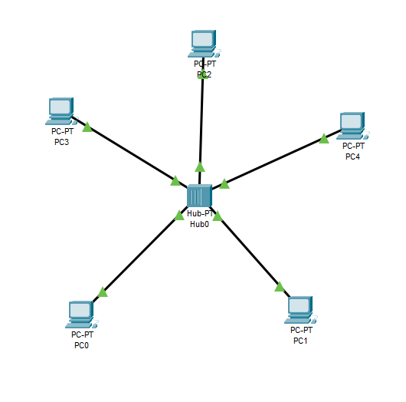

**Step 2**: Configure the IP addresses on the end devices. You will have to access the configuration panel on all devices.

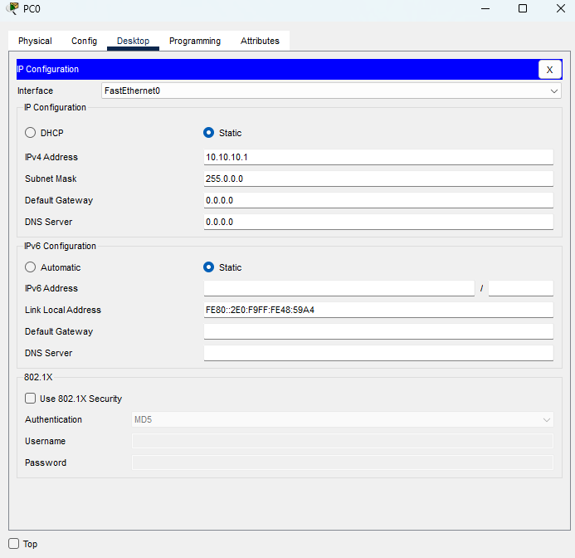

**Step 3**: **Test connectivity**: After configuring the addresses, we will have to test connectivity by opening a command prompt window on the end devices and try pinging the address which the network operates on. If it gives us a reply, it means our network was configured correctly.

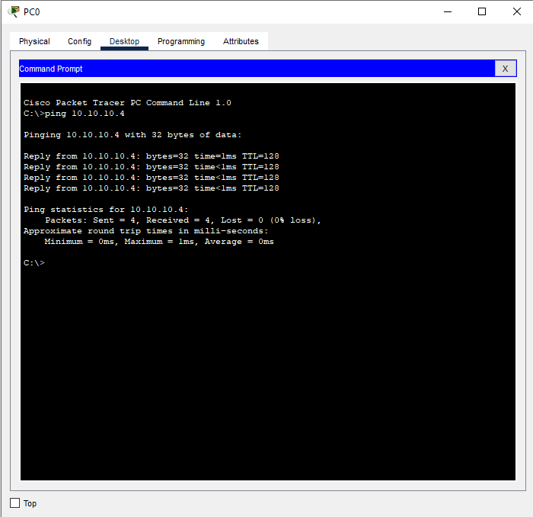

**Practical – 6**

**Aim**: Switch Lan Connection

**Step 1**: Place the system and establish in Switch Lan Connection. A switch is a multiport bridge with a buffer and a design that can boost its efficiency and performance. A switch is a data link layer device. The switch can perform error checking before forwarding data, that makes it very efficient as it does not forward packets that have errors and forward good packets selectively to correct port only. In other words, switch divides collision domain of hosts, but broadcast domain remains same.

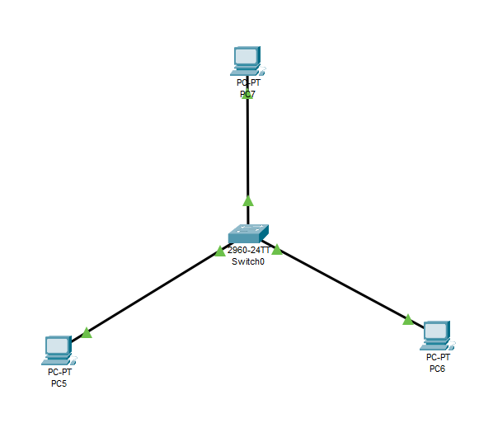

**Step 2**: Configure the IP addresses on the end devices. You will have to access the configuration panel on all devices.

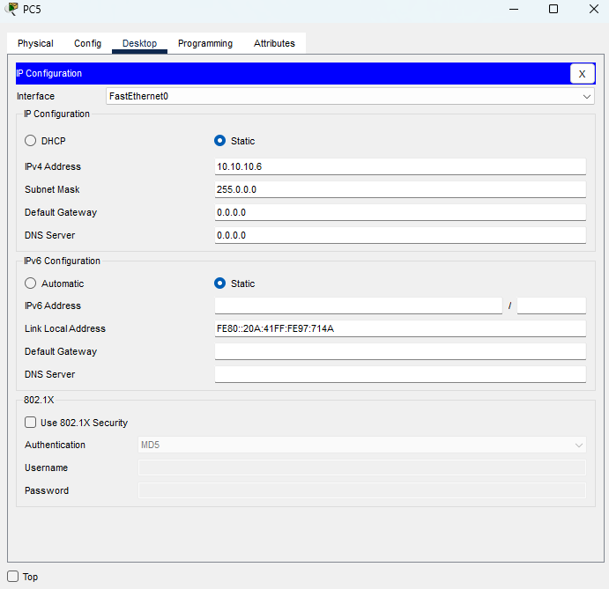

**Step 3**: **Test connectivity**: After configuring the addresses, we will have to test connectivity by opening a command prompt window on the end devices and try pinging the address which the network operates on. If it gives us a reply, it means our network was configured correctly.

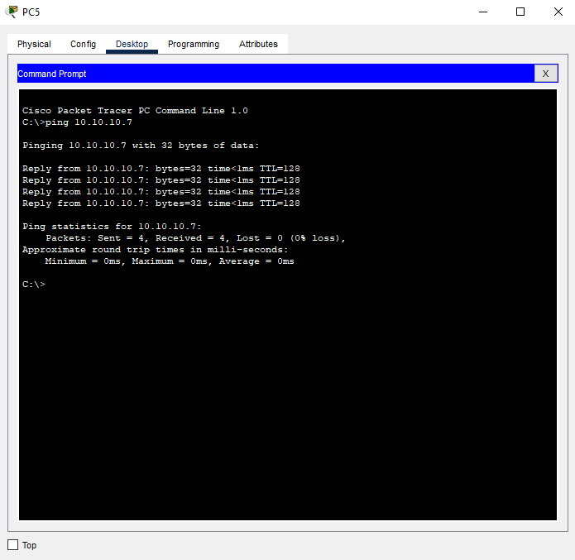

**Practical – 7**

**Aim**: Bus Topology

**Step 1**: Place the system and establish in bus topology. Bus topology is a network type in which every computer and network device is connected to single cable. It transmits the data from one end to another in single direction. No bi-directional feature is in bus topology.

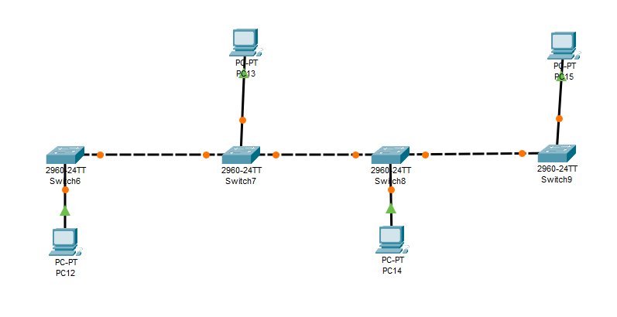

**Step 2**: Configure the IP addresses on the end devices. You will have to access the configuration panel on all devices.

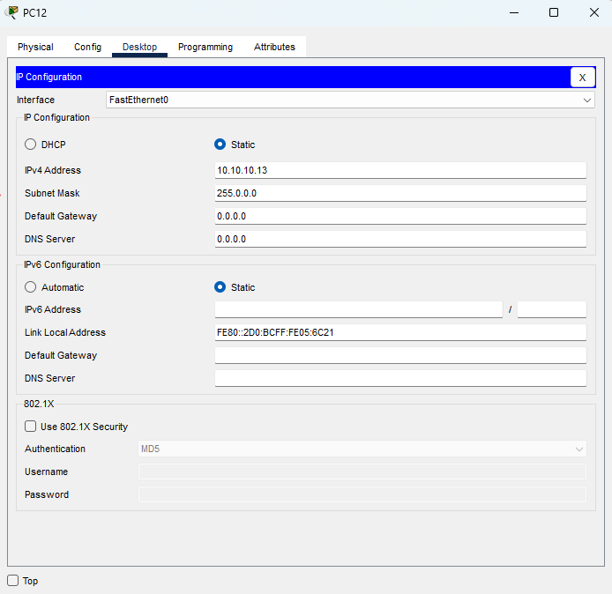

**Step 3**: **Test connectivity**: After configuring the addresses, we will have to test connectivity by opening a command prompt window on the end devices and try pinging the address which the network operates on. If it gives us a reply, it means our network was configured correctly.

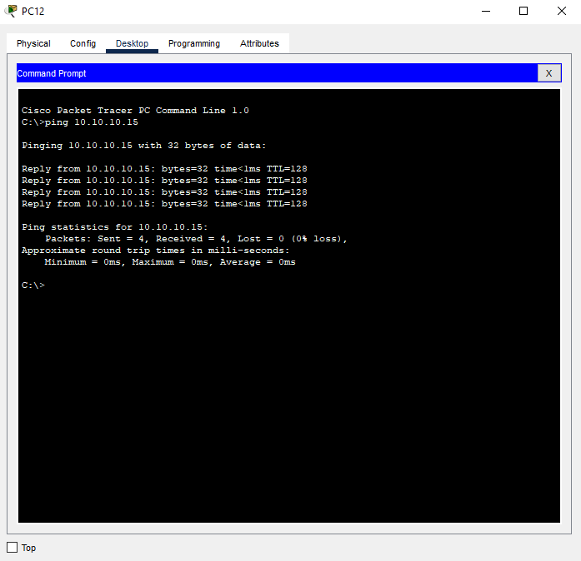

**Practical – 8**

**Aim**: Ring Topology

**Step 1**: Place the system and establish in Ring topology. Ring topology forms a ring connecting a device with its exactly two neighbouring devices. The possibility of collision is minimum in this type of topology.

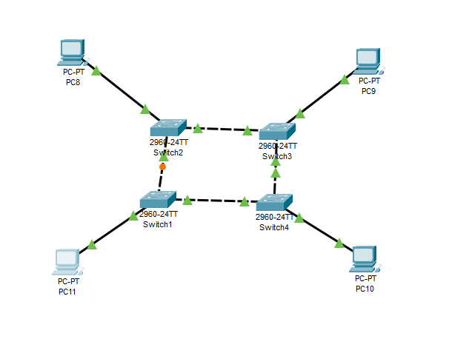

**Step 2**: Configure the IP addresses on the end devices. You will have to access the configuration panel on all devices.

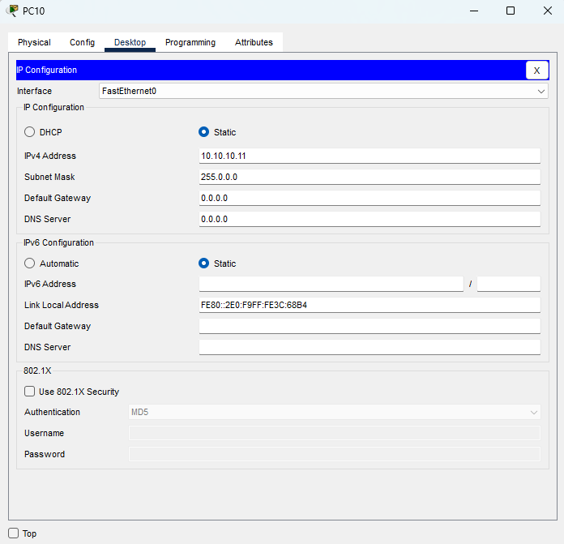

**Step 3**: **Test connectivity**: After configuring the addresses, we will have to test connectivity by opening a command prompt window on the end devices and try pinging the address which the network operates on. If it gives us a reply, it means our network was configured correctly.

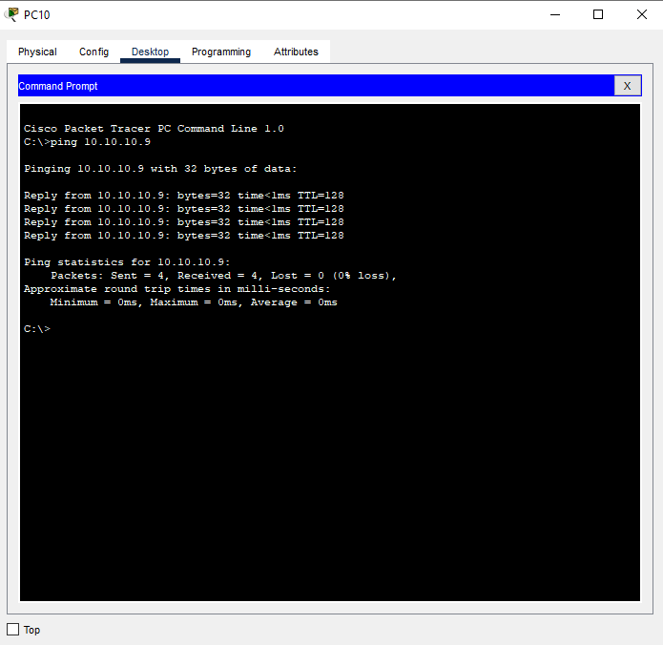

**Practical – 9**

**Aim**: Mesh Topology

**Step 1**: Place the system and establish in Mesh topology. In mesh topology, every device is connected to another device via particular channel. Every device is connected with another via dedicated channels. These channels are known as links.

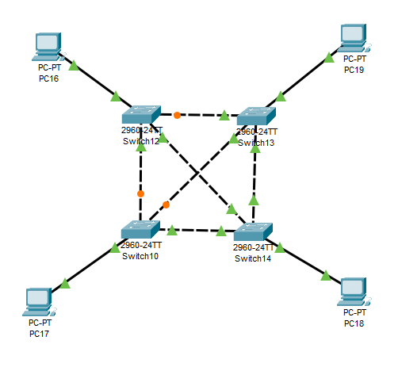

**Step 2**: Configure the IP addresses on the end devices. You will have to access the configuration panel on all devices.

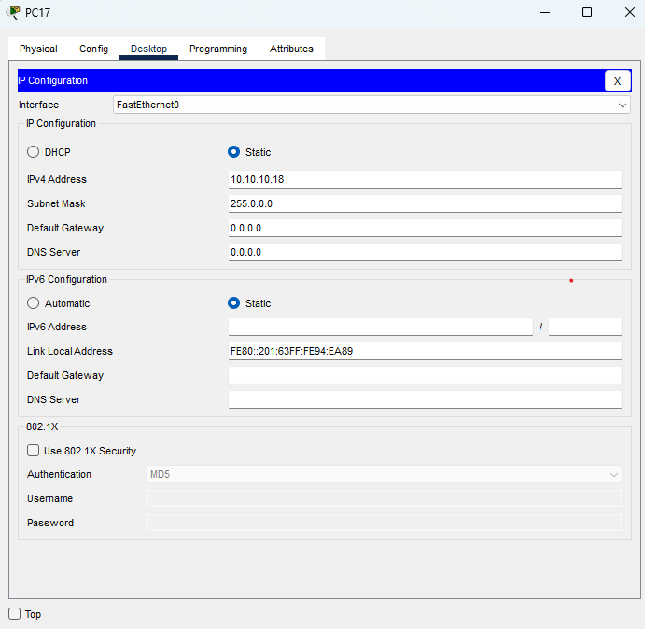

**Step 3**: **Test connectivity**: After configuring the addresses, we will have to test connectivity by opening a command prompt window on the end devices and try pinging the address which the network operates on. If it gives us a reply, it means our network was configured correctly.

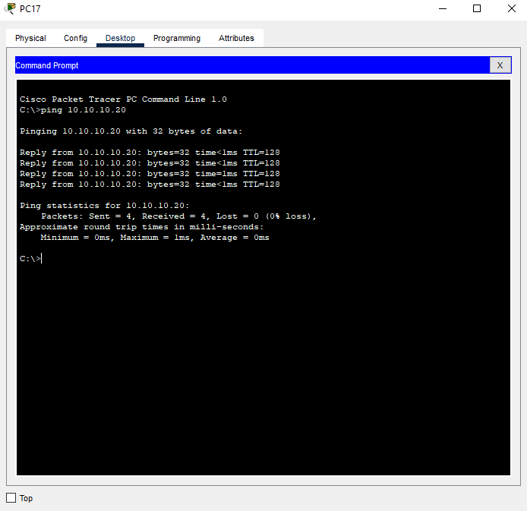

**Practical – 10**

**Aim**: Write a C program to implement Error Detection Technique using checksum calculation.

**Source Code:**

#include<iostream>

#include<conio.h>

#include<string.h>

using namespace std;

int main()

{

char a[20],b[20];

char sum[20],complement[20];

int i;

cout<<"Enter first binary string\n";

cin>>a;

cout<<"Enter second binary string\n";

cin>>b;

if(strlen(a)==strlen(b))

{ char carry='0';

int length=strlen(a);

for(i=length-1;i>=0;i--)

{

if(a[i]=='0' && b[i]=='0' && carry=='0')

{

sum[i]='0';

carry='0';

}

else if(a[i]=='0' && b[i]=='0' && carry=='1')

{

sum[i]='1';

carry='0';

}

else if(a[i]=='0' && b[i]=='1' && carry=='0')

{

sum[i]='1';

carry='0';

}

else if(a[i]=='0' && b[i]=='1' && carry=='1')

{

sum[i]='0';

carry='1';

}

else if(a[i]=='1' && b[i]=='0' && carry=='0')

{

sum[i]='1';

carry='0';

}

else if(a[i]=='1' && b[i]=='0' && carry=='1')

{

sum[i]='0';

carry='1';

}

else if(a[i]=='1' && b[i]=='1' && carry=='0')

{

sum[i]='0';

carry='1';

}

else if(a[i]=='1' && b[i]=='1' && carry=='1')

{

sum[i]='1';

carry='1';

}

else

break;

}

cout<<"\nSum="<<carry<<sum;

for(i=0;i<length;i++)

{

if(sum[i]=='0')

complement[i]='1';

else

complement[i]='0';

}

if(carry=='1')

carry='0';

else

carry='1';

cout<<"\nChecksum="<<carry<<complement;

}

else

cout<<"\nWrong input strings";

return 0;

}

**Practical – 11**

**Aim**: Write a C program to implement bit stuffing.

**Source Code:**

#include<stdio.h>

#include<string.h>

int main()

{

    int i=0, count=0;

    char databits[80];

    printf("Enter Data Bits in the form of zero's and one's:");

    scanf("%s",&databits);

    printf("Data Bits Before Bit Stuffing:%s",databits);

    printf("\nData Bits After Bit Stuffing:");

    for(i=0;i<strlen(databits);i++)

    {

        if(databits[i]=='1')

            count++;

        else

            count=0;

        printf("%c",databits[i]);

        if(count==5)

        {

            printf("0");

            count=0;

        }

    }

    return 0;

}

**Practical – 12**

**Aim**: Write a C program to implement byte stuffing.

**Source Code:**

#include<stdio.h>

#include<fcntl.h>

#include<string.h>

#define flag '*'

#define esc'#'

void main()

{

    int j=1, i, pid;

    char str[50],frame[50];

    printf("Enter a string:");

    scanf("%s",&str);

    frame[0]=flag;

    for(i=0;i<strlen(str);i++)

    {

        if(str[i]==flag||str[i]==esc)

        {

            frame[j]=esc;

            j++;

        }

        frame[j]=str[i];

        j++;

    }

    frame[j++]=flag;

    frame[j]="\o";

    printf("\nFrame to send: %s",frame);

    return 0;

}

**Practical – 13**

**Aim**: Write a C program to implement error detection and error correction technique using CRC.

**Source Code:**

#include<stdio.h>

#include<string.h>

#define N strlen(gen_poly)

char data[28];

char check_value[28];

char gen_poly[10];

int data_length,i,j;

void XOR()

{

    for(j = 1;j < N; j++)

    check_value[j] = (( check_value[j] == gen_poly[j])?'0':'1');

}

void receiver()

{

    printf("Enter the received data: ");

    scanf("%s", data);

    printf("\n-----------------------------\n");

    printf("Data received: %s", data);

    crc();

    for(i=0;(i<N-1) && (check_value[i]!='1');i++);

        if(i<N-1)

            printf("\nError detected\n\n");

        else

            printf("\nNo error detected\n\n");

}

void crc(){

for(i=0;i<N;i++)

      check_value[i]=data[i];

    do{

        if(check_value[0]=='1')

        XOR();

        for(j=0;j<N-1;j++)

        check_value[j]=check_value[j+1];

        check_value[j]=data[i++];

    }

while(i<=data_length+N-1);

}

int main()

{

    printf("\nEnter data to be transmitted: ");

    scanf("%s",data);

    printf("\n Enter the Generating polynomial: ");

    scanf("%s",gen_poly);

    data_length=strlen(data);

    for(i=data_length;i<data_length+N-1;i++)

        data[i]='0';

    printf("\n----------------------------------------");

    printf("\n Data padded with n-1 zeros : %s",data);

    printf("\n----------------------------------------");

    crc();

    printf("\nCRC or Check value is : %s",check_value);

    for(i=data_length;i<data_length+N-1;i++)

        data[i]=check_value[i-data_length];

printf("\n----------------------------------------");

  printf("\n Final data to be sent : %s",data);

    printf("\n----------------------------------------\n");

    receiver();

return 0;

}